
Holy Family Primary School
Newsletter
Friday, 1st December 2017

Pupils of the Week
Class | Name | Reason
Rec | Oran McGloin | For being a good friend to others
Yr.1 NC | Abbie-Leigh Devlin | For her fabulous number 5 work
Yr.1 MP | Tess McAteer | For giving 100% to all aspects of school life
Yr.2 EM | Charlie Hyland | For being such a reliable boy and helping others during our play
Yr.2. FMG | Hayley McCaffrey | For always being a great friend to everyone in class
Yr.3 SM | Christy Johnston | For making such an improvement with his letter formation
Yr.3 UC | Milana Ivanova | For being so focused and meeting her targets
Yr.4 CMM | Ethan Boland | For great work with area
Yr.4 BH/JM | Cara Murphy | For being so animated during our play practices
Yr.5 DMC | Sean McDonagh | For playing so well for the school Gaelic team last Friday!
Yr.5 DMS | Ronan Baxter | For working so hard & being a positive influence on others
Yr.6 SMG | James McKenna | For reading lots of books & taking lots of Accelerated Reader quizzes
Yr.6 ZMD | Lily O’Kane | For being so kind & bringing in homemade treats for the class
Yr.7 CK | Maria Diamond | For always showing a great interest in all curricular areas
Yr.7 KMK | Cormac Chism | For excellent responses & contributions to discussions on our novel

Good Manners Award
Those chosen to receive recognition for the ‘Good Manners’ Award this week are: Phelan Sammons, Cara McVey, Caolan O’Neill, Jessica Moore, Dominick Hegyes, Gosia Bedkowska, Caoimhe Logue, Erin Loughran, Almha Cunningham, Niamh Colton, Ben McCullagh, Callum Coyle, Kirsten Kearns, Clodagh McGlone, Storm McCarron, Ryan Montgomery & Tori Breslin. Well done everyone, we are so proud of you all.

Upcoming Dates to Note
Fri 15th Dec – Open Day for new Reception/Yr.1’s takes place on the Junior Site
Tues 6th March – Yr.4 First Confession
Sat 10th March – Sacrament of Confirmation in the Sacred Heart Church @ 3.00pm
Sun 13th May – Yr.4 First Holy Communion
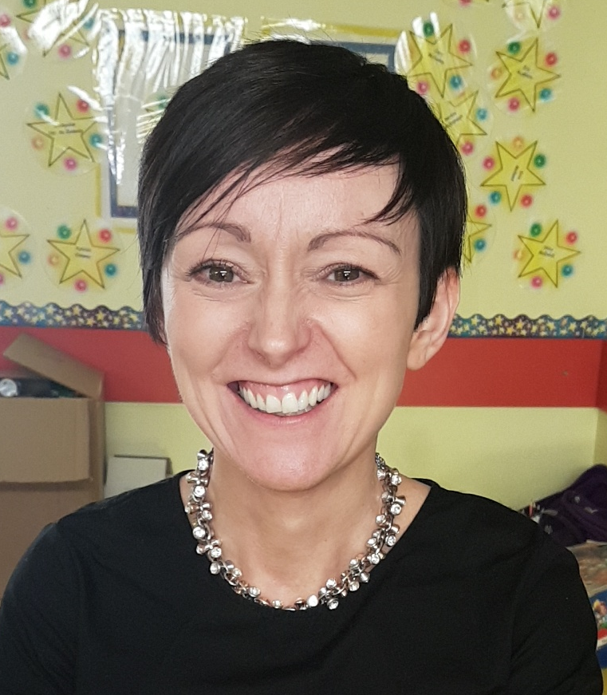
Best Wishes Mrs. McKnight!!
Our good luck wishes go with Mrs. McKnight as she leaves us today to begin her maternity leave!! Mrs. McKnight and her husband Emmet are expecting their first baby in a few weeks - what a wonderful Christmas present for them both!!! We extend a huge Holy Family welcome to Mrs. Noleen Colton who will take Mrs. McKnight’s Yr.7 class until her return. Mrs. Colton has been in during the week to meet with the class and we have no doubt she will be a wonderful asset to our team!!

Reminder: Pre/After School Clubs
We wish to remind parents/guardians that our after school programme has finished for this term. A huge thank you to all our coaches/tutors for providing this service to our pupils. The waiting over facility for Yr.1/Yr.2 on the junior site will continue up to Tuesday, 19th Dec and the Yr.5/6/7 homework club on the senior site will continue until Thursday, 14th Dec.
N.B. Please check with private tutors for their finishing dates:- singing (Orlagh), traditional music (Nuala), piano (Elizabeth) and guitar (Owen).
Timetable of Christmas Events
Date | Time | Event
Tues 5th | 10.00am | Yr.1 Christmas Play for parents/guardians – junior site
Wed 6th | 10.00am | Yr.2 Christmas Play for parents/guardians – junior site
Fri 8th | 10.00am | Yr.3 Christmas Play for parents/guardians – junior site
Mon 11th Dec | 1.30pm | Yr.4 Christmas Play for parents/guardians – junior site. N.B. Please note the change of date & time for the Yr.4 play!!
Tues 12th Dec | 10.00am | Advent Mass in Sacred Heart Church
Wed 13th Dec | Lunch Time | Christmas Lunch will be served in both canteens
Thur 14th Dec | 10.00am | Reception Christmas Play for parents/guardians – junior site
Fri 15th Dec | 9.30am – 10.30am | Open Day on Junior Site
Mon 18th Dec | 1.00pm | Yr.5/6/7 Christmas Carol Service in the Sacred Heart Church
Wed 20th Dec | 12.00noon | School closes for the Christmas break

Christmas Fun Night

Our Christmas Fun Night last night was not only a fantastic, enjoyable, family night for all, but a resounding success in that £5,230 was raised for our school funds. On behalf of the staff and myself, I wish to extend a huge thank you to all our pupils, parents and friends who helped out, attended and supported us at this event, and to all our sponsors in the local community for their generosity. A special thank you to our Parents’ Committee and their families, to whom we are hugely indebted to for all their hard work and dedication during the months leading up to the event. This money will make a great difference to our school resources, and will greatly improve the learning potential and environment for all our children. Our sincerest thanks to everyone.
Name the Teddy - Junior Site: Cora Mimnagh Yr.3U correctly guessed ‘Cuddles’
Name the Teddy - Senior Site: Jamie Duffy Yr.7C correctly guessed ‘Rudolf & Ruby’
Big Ticket Draw: 1st Adrian Colton (£100.00), 2nd Callum McNamee (£50.00), 3rd Rory Garrity (£25.00).
Our Sponsors: Asda, Ashfield Laundrette, Boots Chemist, Bowes Brothers, Bradleys/Castle Pharmacy, Brookmount Pharmacy, Campsie S.S., Cauldwells, Centra Brookmount Road, Centra McCullaghs, Claremount Accountants, Classic S.S., Coach Inn/Village Inn, Corrigan Opticians, Creative Stone & Tile, Credit Union, Crosshill Art Gallery, Danske Bank, Dolans Bridge Street, Dominos, Dunnes Stores, First Trust Bank, Gordons Chemist, Gortrush Trading, Hazel Allen Jewellers, Hi-Tec, Homebase, Image Express, Lakeland Leisure, Lidl, Little House of Beauty, McDermotts Building Supplies, McGarrigles Shoes, McGread’s Medicare, Milan, Mullaghmore Bakery, Omagh Telecom, Orba, P. Fahy, Pat Kirk, Rosemary Cottage, Rue, Russells, Sallys, Serendipity, Shoe Scene, Slevin’s Chemist, Spar Kevlin Road, Sperrin Restaurant, Supervalu, The Meat Joint, The Salon, Top News, Under the Hat, Visioncare, Wattersons and 9th Avenue. Once again a huge thank you to you all.

Congratulations Keenan

Huge congratulations to Keenan Donnelly in Mr. McCusker’s Yr.5 class for being chosen as a winner in the Schools’ Road Safety poster competition. Road Safe N.I. will now produce a 2018 calendar with 20 of the top posters and these will be delivered to schools in the Fermanagh & Omagh District area. Well done Keenan – we hope you have lots of fun spending your £10.00 Erneside gift voucher!!!!

Yr.1 – Yr.7 School Milk for Spring Term
In order for milk to be available when the school reopens on Thursday, 4th January 2018, we will need to submit the milk orders before the Christmas break. If you wish your child to avail of milk in the spring term, please complete the order form below and return to the class teacher, with payment of £11.00, by Friday 15th December.
--------------------------------------------------------------------------------------------------------------------------------------------------------------------

Name of Child: Year:

I/We enclose £11.00 cash/cheque (payable to Holy Family P.S.)

Signed: Date:



1 December 2017

Journey to Santa Challenge
Monday 4th – Friday 15th December 2017

Dear Parent / Guardian,

Our school is joining the Journey to Santa Challenge 2017!

What is it?
Part of the Sustrans Active School Travel Programme, Journey to Santa is a challenge where pupils compete to see who can carry out the most school journeys actively, in the run-up to Christmas.

Pupils who walk, cycle or scoot to school from Monday 4th to Friday 15th December inclusive (10 x school days) will receive a stamp/signature from their class teacher on their Journey to Santa booklet. This can be all or part of the journey.

Pupils can receive one stamp for a morning journey and one for an evening journey.
If a parent walks or cycles with them, they receive an extra stamp.
(Maximum 3 x stamps per school day; maximum 30 x stamps overall)

Any pupils who have received at least 15 stamps/signatures by the end of the Challenge on Friday 15th December will automatically be entered into the Grand Prize Draw!

Why are we taking part?
Sustrans aims to encourage as many children as possible to travel by bike, scooter or on foot on their school journeys. Research has shown that children who travel actively arrive more awake and have better concentration in class.

We understand cycling or walking to school is not possible for every family and there will still be opportunities for your children to participate in other aspects of the Active Travel programme throughout the year.

What do we need to do?
The time of year that this event is being run will mean that parents and children should think carefully about road safety. Please ensure your children and their bicycles are visible by making sure they have lights, fluorescent jackets and reflective strips where possible. They will also need suitable clothing - in particular, waterproof jackets and bicycle helmets to keep them dry and safe.

This event promises to be great fun and we hope you can join us on our Journey to Santa!
Good luck!

Ann-Marie Cox Sustrans Active Travel Officer
annmarie.cox@sustrans.org.uk

