
Holy Family Primary School
Newsletter
Friday, 3rd March 2017
Pupils of the Week
Class | Name | Reason
Rec | Abbie-Leigh Devlin | For being a good friend to others
Yr.1 NC/BH | Aoibhín McNabb-Woods | For her excellent sounding out during her reading
Yr.1 MP | Shea Deazley | For brilliantly acting out the role of Jack (Jack & the Beanstalk)
Yr.2 FMG | Niamh Colton | For great work on measures, well done!
Yr.2. EM | Maria Sidorenko | For all her super contribution to our theme fairy tales
Yr.3 SM | Ella McDermott | For having the most beautiful manners & great listening skills
Yr.3 UC | Kara-Rose Wilson | For great practical work on tens & units
Yr.4 BH/DMC | Bradon Gheel | For excellent reading skills and lovely manners
Yr.4 CMM | Aoife McGarvey | For her positive approach to her daily tasks
Yr.5 PG | Jakub Grzesiak | For consistently producing good work in class
Yr.5 DMS | Emma Catterson | For always having a positive attitude and for being a great friend to everyone
Yr.6 CK | Shania Harkin | For being so lovely all the time!
Yr.6 KMN | Jude Kelly | For fabulous fraction work
Yr.7 SMG | Aidan Gormley | For being so generous and thinking of others
Yr.7 ZMD | Kamile Krzysztofik | For being so helpful in the classroom and being so organised

Good Manners Award


Those chosen to receive recognition for the ‘Good Manners’ Award this week are: Milana Ivanova, Matthew Bryan, Maisy Sharkey, Conor Rice, Michéal McMahon, Jack Kelly, Christopher Hegyes, Cassie Duffy, Feilim McCaul, Marcin Bereszko, Matthew Murray, Catie Peace, Emer McCanny, Ester Preissler, Amelia Stachura, Corey Grimes, Toran Doherty, Alisha Brophy, Orla McGaughey, Megan Prtichard, Abby McEnhill and Cormac Chism. Well done everyone, we are so proud of you all.

Dates to Note
Sun 5th March: Our Yr.7 team will take part in the final of the Credit Union Quiz in Kellys’ Inn @ 2.00pm.
Tues 7th March: Parents’ Committee meeting takes place in the senior site staffroom @ 6.30pm
Tues 7th, Wed 8th & Thur 9th March: School Photographer (see attached)
Sat 11th March: Sacrament of Confirmation in the Sacred Heart Church @ 11.00am
Fri 17th & Mon 20th March: St. Patrick’s Day break
Tues 21st March: PATHS training for parents/guardians @ 5.30pm on senior site (details to follow in the upcoming weeks)

Drumragh GAA
Hurling starts this evening (Fri, 3rd March) from 6.00pm - 7.15pm. Youth training starts tomorrow (Sat, 4th March) at Clanabogan for all children aged 5-11yrs everyone welcome!

Do This in Memory Programme
For parents/guardians convenience here are the remaining dates for the Yr.4 Do This in Memory programme, which takes place at the 6.00pm Saturday Mass in the Sacred Heart Church:- 18th March (Holy Family parents/guardians involved in the readings at this Mass), 8th April (Palm Sunday), 29th April and the 17th June.

Lenten Children’s Liturgy

Each Sunday during Lent, parish youth leaders and the children of Drumragh parish will be celebrating the Lenten Children’s Liturgy. Children will be invited to participate at the start of Mass and will enjoy listening to Bible stories and take part in art activities. The children’s liturgy will take place at the 10.00am Mass in St. Mary’s Church, Drumragh and at the 12.30pm Mass in the Sacred Heart Church, Omagh.


Congratulations to our Footballers!
Last Friday our KS2 girls took part in the Cumann na mBunscol indoor Gaelic competition at the Station Centre. The girls beat off competition from Strabane & Dromore to land a place in the final against Carrickmore and even though we got off to a great start leading 1 - 0 in the opening minutes it was the ‘Carmen’ girls who were victorious at the end!!! Ms. McSorley, who accompanied the girls to the competition, says they were amazing both on and off the court and displayed great sportsmanship by congratulating the winning team – how brilliant is that!!!

Good Luck to our Quizzers!!!
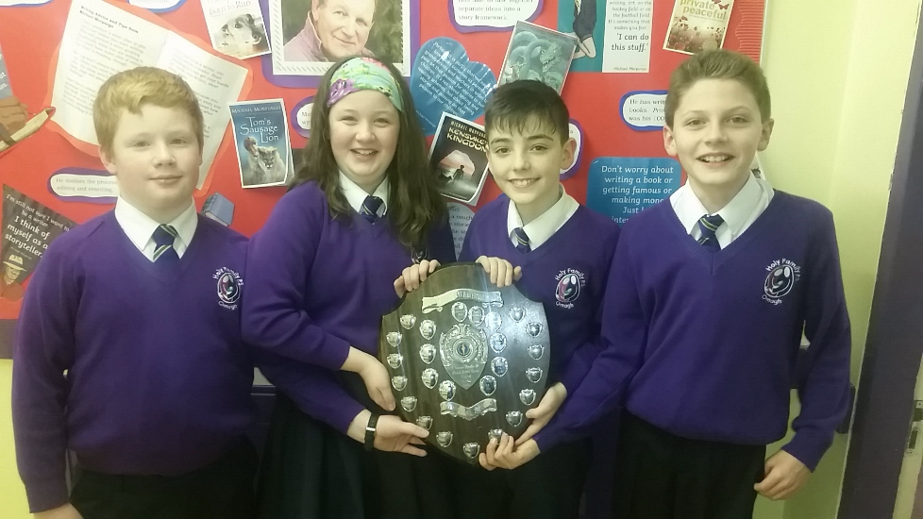
We send best wishes to our Yr.7 quiz team as they take part in the area final of the Credit Union Quiz this Sunday in Kellys’ Inn. The team:- Alice Symington, Henry Symington, Oran McNabb and Conor Pritchard, are representing Tyrone after winning their heat in St. Joseph’s Hall in January. We know they will be great advocates for Tyrone and Holy Family and we will let you know how they get on in next week’s newsletter. The quiz takes place at 2.00pm so if you have nothing else planned for Sunday why not come along and lend your support!!

A Huge Thank You to Aidan
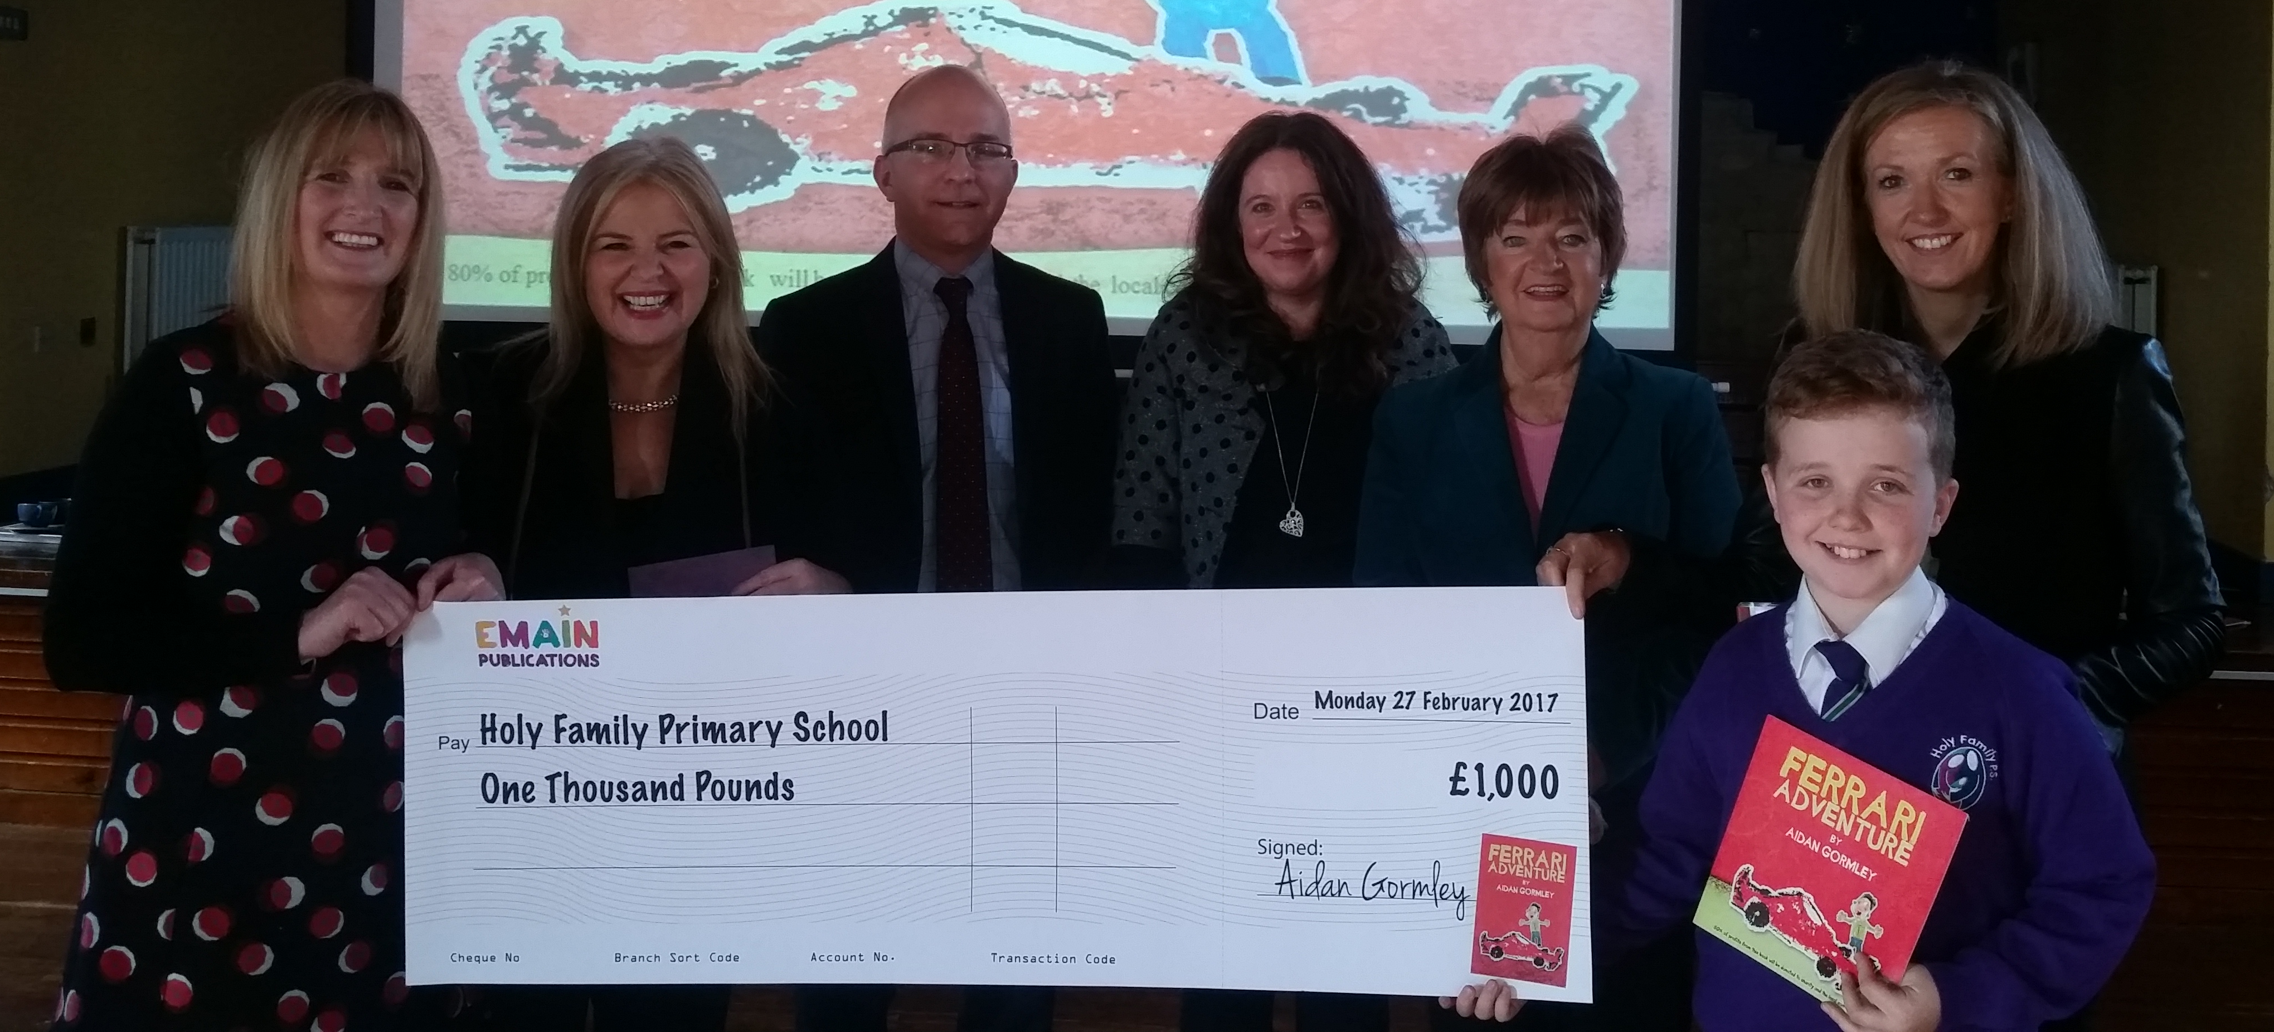
We would like to extend a huge thank you to our resident author Aidan Gormley in Yr.7S, for his very kind donation of £1,000 to Holy Family Primary School. When Aidan was in Yr.3 he wrote a book called ‘Ferrari Adventure’, which he read out to Minister John O’Dowd MLA, at the official opening of Holy Family in December 2012. The book was subsequently published and is currently on sale not only in Ireland, but also in the U.K, Europe and America - what an achievement!! Aidan has also donated £1,000 to the Royal Belfast Hospital for Sick Children. Such a lovely, kind gesture Aidan, your parents and family must be so proud of you. Good luck with the future sales of ‘Ferrari Adventure’ and we look forward to reading your next adventure!!!!

Parents’ Committee 5 Week Draw

We are delighted to announce the winners of the fourth Parents’ Committee 5-week draw which took place during the week. 1st prize £50.00 – Eugene Boyle, 2nd prize £25.00 – Dave Humphries, 3rd prize £10.00 – Anna McCrory, promoter’s prize £5.00 – Charlie Grugan Yr.1. Congratulations to our lucky winners and don’t forget, all draw cards need to be with your child’s class teacher by next Tuesday (7th March) to be included in the fifth & final draw. N.B. You can now visit the ‘Holy Family Omagh Parents & Friends’ page on facebook, where you can see photos of the draw taking place. Please click the like button when you visit the page!!

The Satchel Project
Attached to today’s newsletter is information from The Satchel Project regarding the ‘Cook it Programme’ for parents from Reception – Yr.3, which is coming to Holy Family. This is a free five week parents’ programme run by Satchel staff, which provides participants with the opportunity to gain both practical cookery skills and the knowledge to support them in making healthier food choices. The programme will begin on Thursday, 16th March in St. Joseph’s Hall from 9.30am – 11.30am and crèche facilities will be provided. Places are limited so you are advised to get your form back to the Satchel Project quickly to secure your place!!!

School Photographer


A photographer from County Photos will be visiting the school next week on Tuesday 7th, Wednesday 8th and Thursday 9th March to take individual, class and family photographs. We ask you to please note the following arrangements, complete the reply slip below and return to your child’s class teacher on Monday.

Individual photographs:- The photographer will take individual photos of all pupils in our Reception, Yr.1 and Yr.7 classes. Yr.2 – Yr.6 pupils may have an individual photo taken at their parents/guardians request (see reply slip below).

Class photographs:- Each class will have a group photograph taken and parents/guardians may order a copy.

Family photographs:- Pupils who have a brother/sister currently enrolled in school on either site, may have their photo taken together. Again please indicate this on the reply slip below.

Family Group Photographs:-The photographer has set aside 2 sessions for family group photographs, where parents/guardians are welcome to bring their children and other family members along. Both sessions will take place on the junior site and families can attend either session. If you wish to avail of this opportunity please indicate on the reply slip below.

-------------------------------------------------------------------------------------------------------

School Photographs Reply Slip

I would like my son/daughter in Yr. to have the following photographs taken:-

1. Yr.2 – Yr.6 Individual Photograph ◻
2. Family photograph with brother/sister currently enrolled in school ◻
3. Family Group Photograph - Session 1: Tues 7th from 2.15pm – 3.30pm. ◻
- Session 2: Wed 8th from 8.30am – 9.30am. ◻

Signed: Date:

