
Holy Family Primary School
Newsletter
Friday, 24th March 2017
Pupils of the Week
Class | Name | Reason
Rec | Hannah McCaul | For including everyone in her games
Yr.1 NC/BH | Riley Grimes | For wonderful singing during our morning routine
Yr.1 MP | Dawid Steinborn | For working so hard and finishing his tasks
Yr.2 EM | Tori Sammons | For her excellent contribution to our class discussion on Spring
Yr.2. FMG | Pascal McMenamin | For always working hard & concentrating on tasks
Yr.3 SM | Feilim McCaul | For his fluent, expressive reading – he is a real bookworm!
Yr.3 UC | Emily Mullin | For always setting a good example to her classmates
Yr.4 BH/DMC | Kelvin Sloan | For his fabulous detailed answers, well done!
Yr.4 CMM | Claire McArdle | For great effort in all of her school work
Yr.5 PG | Toran Doherty | For working so hard on his ‘Time’ work
Yr.5 DMS | Aimee Catterson | For being so hardworking & always having a smile on her face!
Yr.6 CK | Sally McMenamin | For being so helpful & reliable and for loving learning!!
Yr.6 KMN | Luke McMorrow | For great discussion throughout our myths/legends lessons
Yr.7 SMG | Alisha Brophy | For her conscientious attitude to her school work
Yr.7 ZMD | Shay Campbell | For great work on PATHS

Good Manners Award


Those chosen to receive recognition for the ‘Good Manners’ Award this week are: Kaelan Devlin, Maria Sidorenko, Riley McLaughlin, Cara Pritchard, Niamh Corrigan, Cara Murphy, Caoimhe Fox, Brajanas Dobrovolskis, Ellen Bingham, Amy Cox, Isibeal Johnston-Doherty, Callum McKeown, Ciaran Murphy, Fianna McGuigan, Dillon Montgomery, Sophie Humphries, William Lowe, Tori Breslin, Ryan Montgomery, Conor Hegarty & Shannon McGinn. Well done everyone, we are so proud of you all.

Dates to Note
Mon 27th March – Our senior choir will participate in the semi-final of the BBC Radio Ulster School Choir of the Year in Dalriada School, Ballymoney
Tues 28th March – Yr.5 Showcase in the Strule Arts Centre (see overleaf)
Wed 12th April – School finishes at the normal home-times and the Easter holidays begin
Mon 24th April – School re-opens for the summer term
Sun 21st May – First Holy Communion @ 12.30pm in the Sacred Heart Church

Do This in Memory Programme
For parents/guardians convenience here are the remaining dates for the Yr.4 Do This in Memory programme, which takes place at the 6.00pm Saturday Mass in the Sacred Heart Church:- 8th April (Palm Sunday), 29th April and the 17th June.

Irish Dancing Costume
If anyone is interested in purchasing a McGirr’s school of dancing costume, please contact Catherine on 07745 087 598. The costume is suitable for a 12 – 15yr old and is in immaculate condition.
Good Luck to our Fabulous Choir
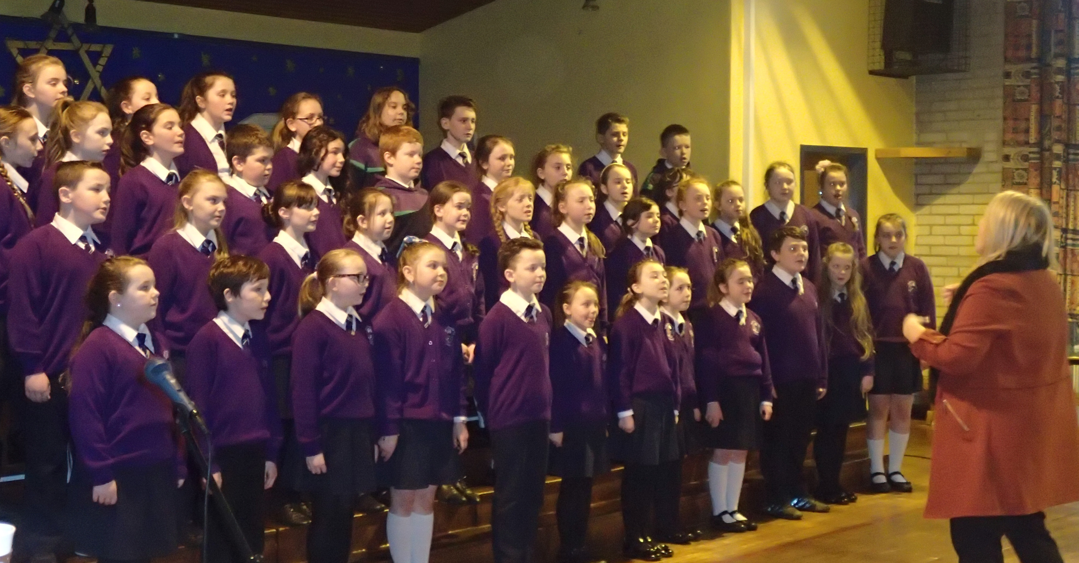
Our good luck wishes go with the senior choir this Monday as they travel to Dalriada School in Ballymoney to take part in the semi-final of the BBC Radio Ulster School Choir of the Year!! There will be 6 choirs taking part in the primary section, including our neighbouring school St. Lawrence’s in Fintona, and 3 will be chosen for a place in the final! Mrs. Dolan, Paul and the choir have been practising really hard over the past number of weeks and we’re not one bit biased when we say they sound absolutely fantastic!!! They have a very early start on Monday morning as the bus will be leaving the front of the senior site at 7.30am – however we know they will be wide awake and ‘ready for action’ by the time they reach Dalriada School. We wish them all the best of luck and a safe journey to and from Ballymoney.

PATHS Training
The feedback we’ve received from those of you who attended the PATHS training for parents/guardians on Tuesday evening has been very positive. A huge thank you to Ms. Martina Luiten, for coming along to deliver the training and being so generous with her time. We hope you found the experience worthwhile and gained a greater insight into the programme your child is involved with in school. We will keep you informed of any further training which may be offered in the future!


Yr.5 Pupils Performing at the Strule Arts Centre!
As part of the Primary Schools’ Céilí project, our Yr.5 classes have been learning Irish dancing with Mr. Kevin Goodwin, Oifigeach na Gaeilge, FermanaghOmagh District Council. The children have had a great time learning the skills involved in Céilí dancing along with their partners from Omagh County Primary. The pupils will all meet up in the Strule Arts Centre next Tuesday (28th March) from 11.20am – 12.45pm to showcase all they have learned and parents/guardians are more than welcome to come along to watch from the balcony.

Mobile Phones
In recent weeks we have noticed a substantial increase in the number of pupils taking mobile phones into school on the senior site. Mobile phones should not be brought into school unless it has been agreed with the Principal and is absolutely necessary i.e. if a pupil is walking home after school & parents/guardians wish them to have their phone. In this instance phones must be handed in to the office in the morning and collected at the end of the school day. There is no need for pupils to bring phones into school, as if a parent or child needs to make contact during the day, they can do so through the school offices (junior site: 8224 4140/senior site: 8224 3551).

Orders for School Milk
If you wish your child to avail of milk in the summer term, please complete the order form below and return to their class teacher, with payment of £9.00, before Wednesday 12th April. No orders for milk will be taken after this date!
-----------------------------------------------------------------------------------------------------------------------------------------------------

Milk Order for Summer Term

Name of Child: Year:

I/We enclose £9.00 cash/cheque (payable to Holy Family P.S.)

Signed: Date:

